Name: _______________________________________________
Foundation Unit 7 topic test
Date:
Time: 60 minutes
Total marks available: 57
Total marks achieved: ______

Questions
Q1.
Here is a list of numbers.
12 19 12 15 11 15 12 13 17
Find the median.
...........................................................
(Total for Question is 2 marks)

Q2.
Here are four number cards.
One of the cards is turned over so you cannot see the number on it.
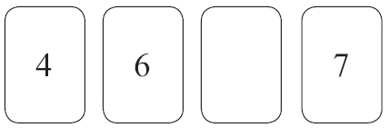
The mean of the four numbers is 6
Work out the number you cannot see.

..............................................................................................................................................
(Total for Question is 3 marks)

Q3.
Here is the number of goals a hockey team scored in each of 10 matches.
Find
(i) the median

..............................................................................................................................................
(ii) the range

..............................................................................................................................................
(iii) the mean

..............................................................................................................................................
(Total for Question is 6 marks)

Q4.
The table shows the midday temperature on each day for ten days.
Day | 1 | 2 | 3 | 4 | 5 | 6 | 7 | 8 | 9 | 10
Temperature (°C) | 13 | 14 | 12 | 10 | 13 | 16 | 14 | 13 | 18 | 16
(a) Find the range of temperatures.

. . . . . . . . . . . . . . . . . . . . . .°C
(2)
(b) Write down the mode.
. . . . . . . . . . . . . . . . . . . . . .°C
(1)
(c) Work out the mean temperature.

. . . . . . . . . . . . . . . . . . . . . .°C
(2)
(Total for Question is 5 marks)
Q5.
Seven people entered a singing competition.
Here are the number of points that each of the first six people scored.
10 8 5 13 18 15
(a) Work out the range for these six people.

...........................................................
(2)
(b) Work out the median for these six people.
...........................................................
(2)
The mean for the seven people was 12
(c) Work out how many points the seventh person scored.
...........................................................
(2)
(Total for Question is 6 marks)

Q6.
Here are the heights, in metres, that 10 men jumped in a high jump competition.
2.19 | 2.23 | 2.23 | 2.23 | 2.26 | 2.28 | 2.29 | 2.29 | 2.31 | 2.33
(a) For these heights, find
(i) the mode,

. . . . . . . . . . . . . . . . . m
(ii) the mean,

. . . . . . . . . . . . . . . . . m
(iii) the range.

. . . . . . . . . . . . . . . . . m
(4)
In a high jump competition for women, the heights, in metres, that 10 women jumped were recorded.
For these heights
the mean was 1.95 m
the range was 0.18 m
(b) Compare the heights that the men jumped with the heights that the women jumped.
..............................................................................................................................................
..............................................................................................................................................
..............................................................................................................................................
..............................................................................................................................................
(2)
(Total for Question is 6 marks)

Q7.
There are 25 students in a class.
12 of the students are girls.
Here are the heights, in cm, of the 12 girls.
 | 160 | 173 | 148 | 154 | 152 | 164 | 179 | 164 | 162 | 174 | 168 | 170
(a) Show this information in an ordered stem and leaf diagram.

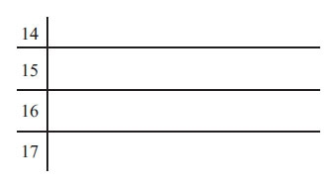
(3)
There are 13 boys in the class.
Here are the heights, in cm, of the 13 boys.
 | 157 | 159 | 162 | 166 | 168 | 169 | 170 | 173 | 174 | 176 | 176 | 181 | 184
* (b) Compare the heights of the boys with the heights of the girls.

(3)
(Total for Question is 6 marks)

Q8.
Yan recorded the ages, in years, of a sample of people at a fairground.
He drew this stem and leaf diagram for his results.
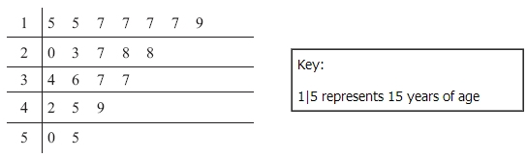
(a) Write down the number of people in the sample.

...........................................................
(1)
(b) Write down the mode.

...........................................................years
(1)
(c) Work out the range.

...........................................................years
(2)
(Total for Question is 4 marks)

Q9.
Zoe recorded the heart rate of each of 15 people.
She showed her results in a stem and leaf diagram.
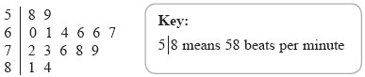

(a) Find the median heart rate.
. . . . . . . . . . . . . . . . . beats per minute
(1)
(b) Work out the range of the heart rates.
. . . . . . . . . . . . . . . . . beats per minute
(2)
Zoe then asked the 15 people to walk up some stairs.
Zoe recorded the heart rates again.
She used the results to work out the median and the range.
Median | 78
Range | 37
(c) Compare the heart rates of the people before they walked up the stairs with their heart rates after they walked up the stairs.
..............................................................................................................................................
..............................................................................................................................................
..............................................................................................................................................
..............................................................................................................................................
(2)
(Total for Question is 5 marks)

Q10.
There are 1200 students at a school.
Kate is helping to organise a party.
She is going to order pizza.
Kate takes a sample of 60 of the students at the school.
She asks each student to tell her one type of pizza they want.
The table shows information about her results.
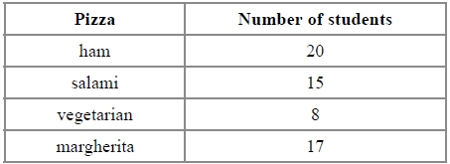
Work out how much ham pizza Kate should order.
Write down any assumption you make and explain how this could affect your answer.

.............................................................................................................................................
.............................................................................................................................................

(Total for question = 3 marks)

Q11.
Mrs Smith gave her students a history test.
The bar chart shows information about the students' marks.
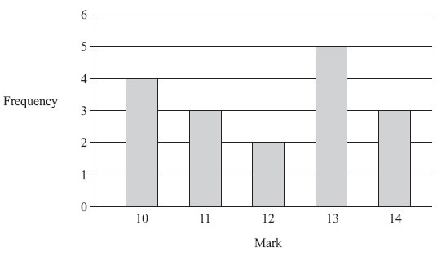
(a) Write down the number of students who got 10 marks.
..............................................................................................................................................
(1)
(b) Write down the mode.
..............................................................................................................................................
(1)
(c) Which two marks have the same frequency?
..............................................................................................................................................
(1)
(d) Work out the range.
..............................................................................................................................................
(2)
(e) How many students did the test?
..............................................................................................................................................
(2)
(Total for Question is 7 marks)

Q12.
The table shows some information about the foot lengths of 40 adults.
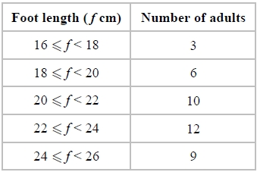
(a) Write down the modal class interval.
...........................................................
(1)
(b) Calculate an estimate for the mean foot length.
........................................................... cm
(3)

(Total for question = 4 marks)

Examiner's Report
Q1.
A fairly typical response for this question was to give the answer of 11 i.e. the candidates gave the middle value of the original list rather than ordering the list first. There were also those cases where the candidates gave the mode and some even calculated the mean. Many candidates chose to use 8 of the numbers instead of 9 and lost marks because of carelessness.

Q2.
This question was generally answered well. A large number of candidates opted for a trial and error approach and many were able to reach the correct final answer. It was, however, quite common to see 6 (the mean) given as the final answer after correct working had been shown. Some candidates added the three numbers given but did not know how to proceed with some dividing the total by 3. Those who gained no marks generally just wrote a number, eg 5, that looked like it fitted the pattern of the given cards.

Q3.
Some candidates got confused between the various statistical measures in this question and correct calculations were often seen in the wrong places.
Most candidates were able to order the given data in part (i) and use the middle values to work out the median. Common incorrect answers seen were 3, 4 (both the middle terms) and 3, 5 (both the middle terms of the unordered data).
In part (ii) most candidates were able to work out the range of the numbers. A small number of candidates gave their final answer as 2, 6.
Part (iii) of this question was done quite well but a significant number of candidates did not show any working. When working was present it frequently lacked a final division by 10.

Q4.
Confusion between range and the averages caused problems for candidates in this question. In part (a) 50% found the correct range but others found the difference between the first and last temperatures listed. 6 was a common incorrect answer from incorrect selection of either 10 and 16 or 12 and 18 as the lowest and highest values. A single mark was rarely awarded although 10-18 was occasionally seen.
75% of candidates correctly gave the mode in part (b) with others usually giving an incorrect average. In part (c), about 50% of candidates calculated the correct mean but many gave another average, often the median, instead. Typical errors with calculator use led to an answer of 124.6 and others rounded the final answer to 14. In both cases it was essential for working or a previous answer of 13.9 to be seen for the award of marks.

Q5.
This was quite well answered with little confusion between the three statistical calculations requested. In part (b) numbers were usually ordered, but weaker students were confused by not having a single number in the centre of their list, sometimes choosing either one of the numbers as their answer, to find the mean of their two numbers. In part (c) the most common error was in calculating 12 × 6 rather than 12 × 7.

Q6.
There is always some confusion between the various statistical measures. Candidates find it difficult to remember which one is which. This appeared to be less of a problem than in previous series, with many candidates picking up full marks. In calculating the mean candidates should always be advised to write down the full answer from their calculator. Some rounding (to 2.26) was allowed, but further than this was penalised.
In part (b) the question asked for a comparison, with the mean and range given. Most candidates wrote something about the mean and range, but it was rarely a comparison.
Frequently they copied down the figures, or worked out the difference. What was really needed was a written summative statement using descriptive terms, which is why lines were printed for the answer.

Q7.
In part (a), most candidates understood what a stem and leaf diagram entailed. The most common mistakes included omitting a key and providing an unordered diagram. Around a quarter of candidates scored no marks but typically did so by either giving a tally in each row or showing full numbers rather than just the units. Students need to be reminded to count the number of pieces of data in the question and to check they have the same number in the completed diagram.
Following on from part (a), many candidates drew a stem and leaf diagram for the boys in part (b). In these instances the majority did not use their diagram to identify key features of the data such as median and range and therefore failed to make a valid comparison. Candidates who carried out calculations often included the mode and median and were awarded marks for the median. At this level, weaker candidates calculated the range but were unable to interpret it as 'spread' correctly. Candidates who calculated the mean were generally able to give a valid comparison. A significant number scored 0 as a result of only comparing the smallest and tallest boy/girl or by making other unqualified statements having completed no calculations.
In a starred question such as this it is essential that students understand that any comparative statements must involve quotation of statistics, their interpretation and a clear link back to the context of the data, in this case the heights of the boys and the girls.

Q8.
This question was usually well answered, although an answer of 7 in part (b) was common.
In part (c), the usual error was to subtract 15 from 50 or 0 from 9.

Q9.
Many candidates scored some marks on this question. There were often able to find the median from the stem and leaf diagram although 66 was a common error. The range was less successfully answered. Most candidates showed no working for this part of the question. Those that did, with incorrect answers, used 81 as the largest value. Another common error was just to give 58 as the range. In part (c) candidates were expected to compare, whilst many wrote the correct managed to say something plausible for the raise in the median values, few pupils made correct comments about the increase in the range. Too many candidates gave long explanations about what exercise does to your body and did not concentrate on the mathematics.

Q10.
No Examiner's Report available for this question

Q11.
Part (a) was accessible for almost all candidates. The majority answered part (b) correctly and part (c) was also very well answered.
Part (d) showed a wide variety of answers. The most common misconception was that the range was calculated by finding the difference between the largest and smallest frequencies, ie 5 − 2 = 3. Another error was taking the same two frequency columns and finding the difference between the two marks, ie 13 − 12 = 1. Another error was to take the total number of students and divide by 5 to obtain the answer 3.4. On occasions, candidates thought that the range and the median were the same and wrote the full list of marks in order, starting with the smallest, and crossed them off from each end to obtain a range of 13.
In part (e), some candidates thought that the total number of students was found either by 10 + 11 + 12 + 13 + 14 = 60 or the previous calculation, and dividing the 60 by 5 to get the answer 12. Many added the vertical axis values as opposed to the bar heights getting 1 + 2 + 3 + 4 + 5 = 15. Of those who tried the correct method, too many could not add the five single-digit numbers correctly and an incorrect answer of 18 was commonly seen.

Q12.
No Examiner's Report available for this question

Mark Scheme
Q1.
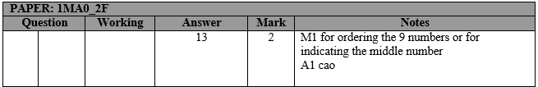

Q2.
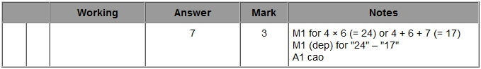

Q3.
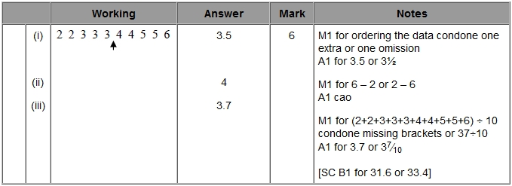

Q4.
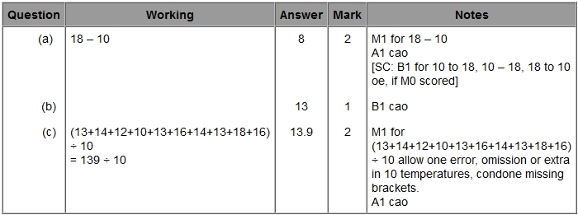

Q5.
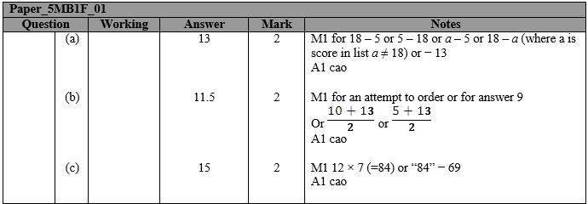

Q6.
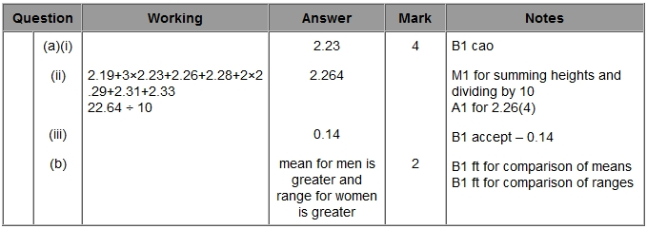
Q7.
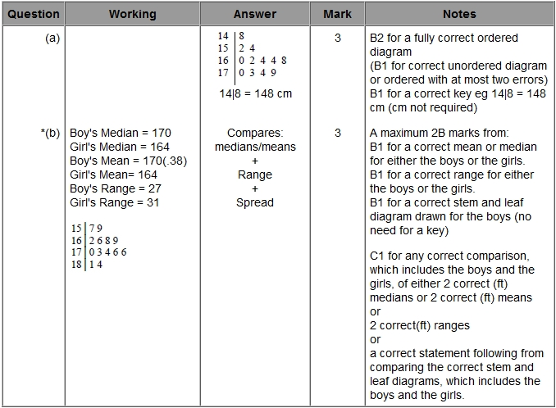

Q8.
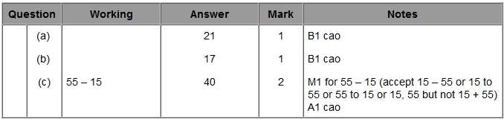

Q9.
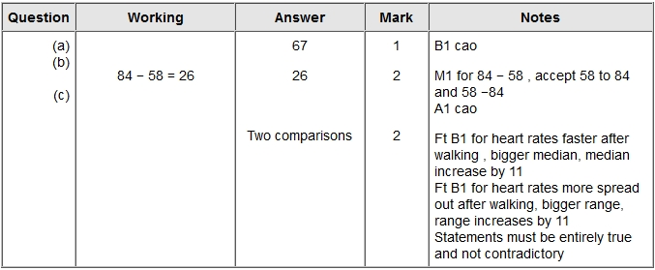

Q10.
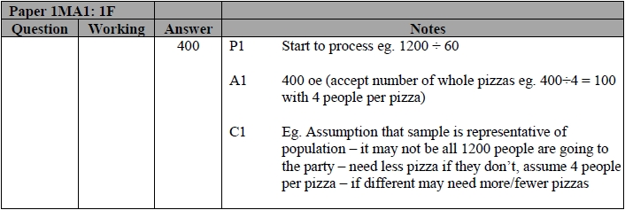

Q11.
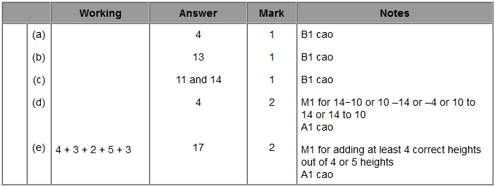

Q12.
